January 2022
Upcoming Events and Important Dates
Virtual Family Gatherings | February and March 2022
Many thanks to the families who joined us for our first virtual gathering in January. We’re grateful for the welcome from Elder Wilson Bearhead, the questions and conversation from attending families, and for your patience as we work through spotty internet connections from our homes!
We look forward to seeing you all again in February and welcome any families who wish to join us. Elder Wilson will again open our gathering, followed by a short presentation from our friends at Rupertsland Institute to share the programs and supports they offer for Métis children and families. We’ll then have time for any discussion or questions and comments families wish to share regarding Indigenous education or supports within EIPS.
The theme for our third gathering in March will depend on what families have shared in the first two gatherings. If there’s a specific topic or idea you’d like the group to discuss, please reach out to someone from the First Nations, Métis and Inuit Education team directly:
- jeremy.albert@eips.ca
- harlee.mcarthur@eips.ca
- cheryl.devin@eips.ca
Sessions will take place online using Microsoft Teams Meetings. Join on your computer or mobile app. If you are interested in attending, please email one of the First Nations, Métis and Inuit Education team members for the log in code.
- Gathering 2: Feb. 15, 2022 (7–8 p.m.)
- Gathering 3: March 15, 2022 (7–8 p.m.)

Direct Student Support
Study Help for Métis students Rupertsland Institute has secured access to Alberta ExamBank for K-12 Métis students to test their understanding through online practice. Métis students can sign up for the RECC Room to find the login for their MNA Region. Questions? Contact education@rupertsland.org.
Is your child in Grade 12 and looking to move on to post-secondary education? There are a variety of scholarships, bursaries and grants available to First Nations, Métis and Inuit students to attend trade school, college or university. Talk to your child’s lead teacher for more information or support in filling out applications.
2022 marks the beginning of the Decade of Indigenous Languages as declared by The United Nations General Assembly. The First Nations, Métis and Inuit Education team would like to begin gathering information that informs us on how to move forward with language learning opportunities for EIPS students and families. We invite families to complete a short online survey as one of our first steps in envisioning what language learning can look like in our Division. We’re excited to think of the possibilities for students and families and thank you in advance for your input and ideas. The survey will remain open until the end of February. Thank you also to the family members in our January virtual gathering for sharing their wishes for Indigenous language opportunities.
We are thankful for questions posed during the virtual gathering and wanted to share the answers with all families:
- Are sharing circles offered at EIPS schools?
First Nations, Métis and Inuit Education team members do visit schools and facilitate sharing circles for students. If you’re interested in this opportunity for your child at his/her school, reach out to your school’s lead teacher to chat.
- Do EIPS schools participate in smudging?
EIPS does have a smudging policy and guiding document for schools written with guidance from Elder Wilson—AP 159: Smudging in Division Facilities. After guidance from Elder Wilson or members of the First Nations, Métis and Inuit Education team, some schools within EIPS offer regular smudging opportunities for students who wish to have access to the ceremony at school. Upon parent request, First Nations, Métis and Inuit Education team members can work with other Division schools to ensure smudging is respectfully and freely available for any students wanting to do so at school. Please reach out to Jeremy.Albert@eips.ca to chat further if you’re interested.
Resources of Interest
Tutoring Support
Did you know? Edmonton Public Library offers free tutoring support for anyone with an EPL library card? Check out all of the supports for students they offer.
Alberta Education has launched online tutorial videos for students as well. New materials will continue to be added in the coming months.
Cree Language Learning
Families at our January virtual gathering also requested information about online Cree language courses being offered. Here are some that might be of interest to families:
- The Centre for Race and Culture is once again offering beginner and intermediate Cree language classes with program coordinator and instructor Reuben Quinn. Refer to the website for descriptions, dates and support resources.
- Portage College also offers online Cree classes.
Rupertsland Institute has officially launched a suite of new supports for Metis students and their families.
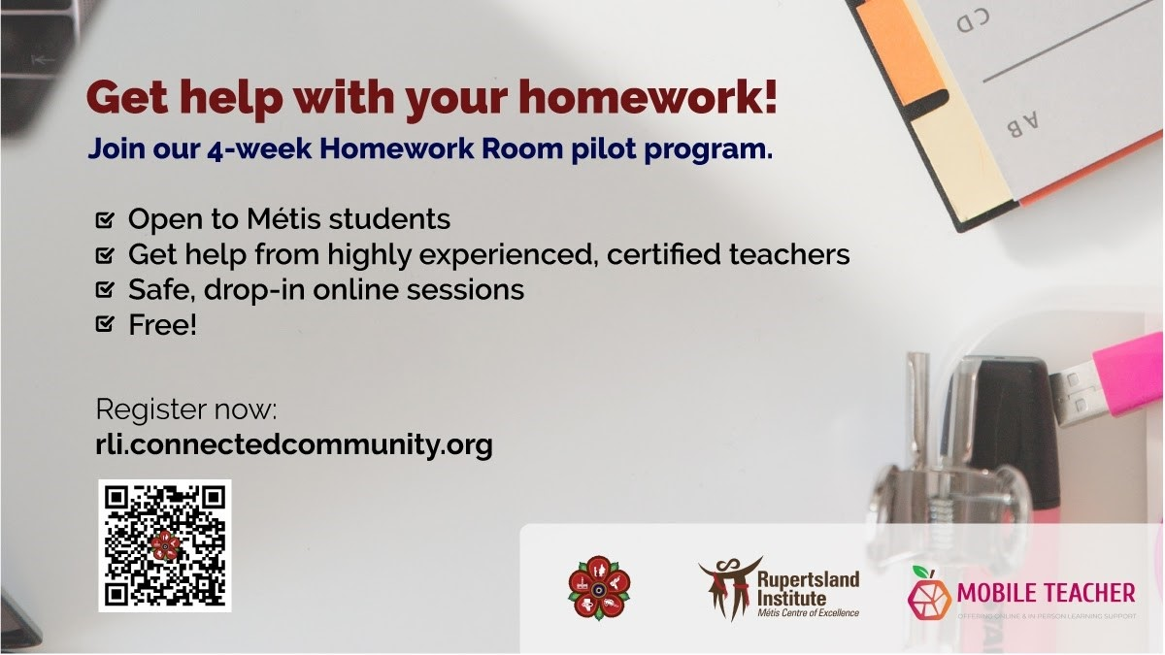
Rupertsland Institute is providing a drop-in Homework Room Program for Métis students. This online drop-in session for Métis learners seeking help with homework and school assignments. Support provided through Mobile Teachers, starting on February 1st.
Tuesdays - Elementary (4-6pm)
Wednesdays - Junior High/High School (4-6pm)
Questions? Please email education@rupertsland.org
Sign-in through the RECC Room https://rli.connectedcommunity.org/home to access Zoom links!
Did you know that RLI has secured access to Alberta ExamBank for K-12 Métis Students to test their understanding through online practice? Métis students can sign up for the RECC Room to find the login for their MNA Regions HERE https://rli.connectedcommunity.org/
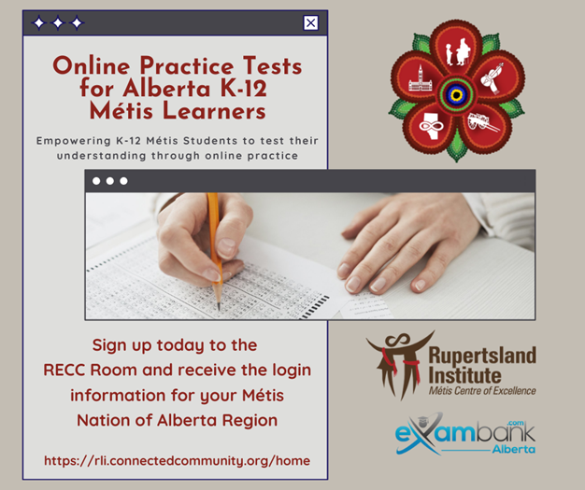
Questions? Contact education@rupertsland.org!
Caregivers and Parents of Métis early learners, join RLI and Totally Talking for a workshop about Language and Speech Development in our Young Children: Exploring Read Alouds and Board Games for our Preschool Children at 7:00PM MST on February 17, 2022.
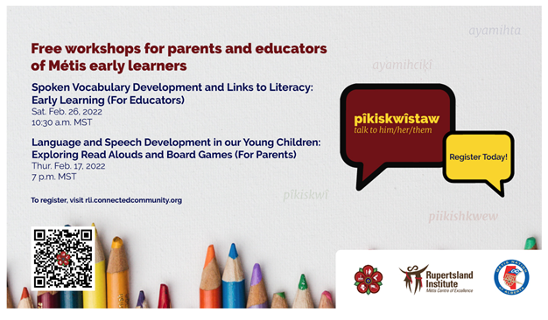
Register here by 4:00PM MST on February 16, 2022 https://rli.connectedcommunity.org/home
Calling all caregivers and parents of Métis early learners! Beginning in January 2022 until June 2022, Métis Nation of Alberta citizens can apply to Rupertsland Institute for the cost of preschool fees for children interested in attending registered preschools in Alberta (limited funds available). Successful applicants who sign up will receive a welcome package!
Head to the RECC Room to learn more: https://rli.connectedcommunity.org/home
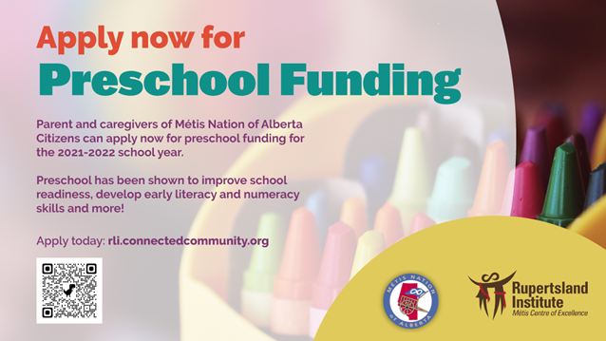

JOIN Métis artist Angela Hall and RLI on Friday, February 25, 2022 from 1-2:30pm for our next free Métis Wellness and Cultural Art Virtual gathering geared towards Grades 4-12! Head to https://rli.connectedcommunity.org/home to sign up! NOTE: If you have already signed up for the series there is no need to sign up again.
Everyone welcome!
